# Design asp.net web form to demonstrate various events in asp.net page life cycle.

**Design:**

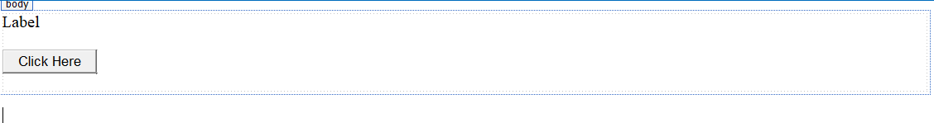

# Code: PageLifeCycle.aspx

<%@PageLanguage="C#"AutoEventWireup="true"CodeBehind="PageLifeCycle.aspx.cs"In herits="practical2_A.PageLifeCycle"%>

<!DOCTYPEhtml>

<htmlxmlns="<http://www.w3.org/1999/xhtml>">

<headrunat="server">

<title></title>

</head>

<body>

<formid="form1"runat="server">

<div>

<asp:LabelID="lblName"runat="server"Text="Label"></asp:Label>

<br/>

<br/>

<asp:ButtonID="Button1"runat="server"Text="Click Here"/>

<br/>

<br/>

</div>

</form>

</body>

</html>

# PageLifeCycle.aspx.cs:

using System;

using System.Collections.Generic; using System.Linq;

using System.Web; using System.Web.UI;

using System.Web.UI.WebControls;

namespace practical2_A

{

publicpartialclassPageLifeCycle : System.Web.UI.Page

{

protectedvoid Page_PreInit(object sender, EventArgs e)

{

lblName.Text = lblName.Text + "<br/>" + "PreInit";

}

protectedvoid Page_Init(object sender, EventArgs e)

{

lblName.Text = lblName.Text + "<br/>" + "Init";

}

protectedvoid Page_InitComplete(object sender, EventArgs e)

{

lblName.Text = lblName.Text + "<br/>" + "InitComplete";

}

protectedoverridevoid OnPreLoad(EventArgs e)

{

lblName.Text = lblName.Text + "<br/>" + "PreLoad";

}

protectedvoid Page_Load(object sender, EventArgs e)

{

lblName.Text = lblName.Text + "<br/>" + "Load";

}

protectedvoid btnSubmit_Click(object sender, EventArgs e)

{

lblName.Text = lblName.Text + "<br/>" + "btnSubmit_Click";

}

protectedvoid Page_LoadComplete(object sender, EventArgs e)

{

lblName.Text = lblName.Text + "<br/>" + "LoadComplete";

}

protectedoverridevoid OnPreRender(EventArgs e)

{

lblName.Text = lblName.Text + "<br/>" + "PreRender";

}

protectedoverridevoid OnSaveStateComplete(EventArgs e)

{

lblName.Text = lblName.Text + "<br/>" + "SaveStateComplete";

}

protectedvoid Page_UnLoad(object sender, EventArgs e)

{

lblName.Text = lblName.Text + "<br/>" + "UnLoad";

}

}

}

# Output:

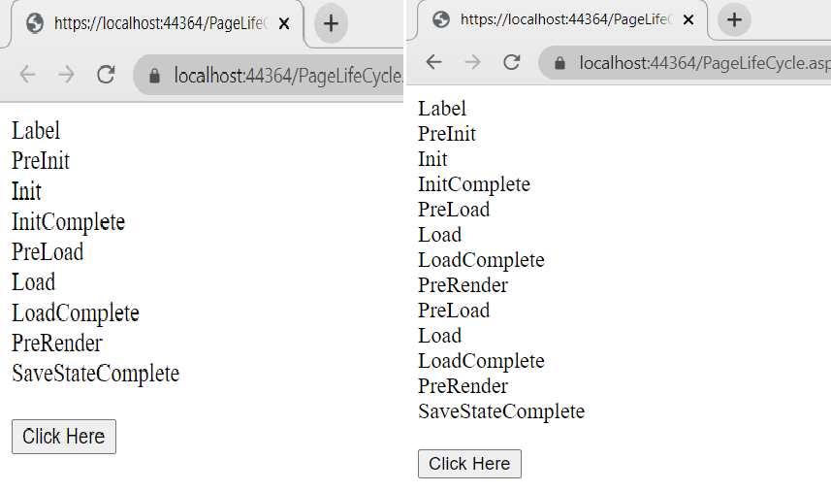

1. **Design asp.net web form to demonstrate postback posting, cross-page posting and auto postback.**

# Design:

**Code:**

# Gui1.aspx.cs:

using System;

using System.Collections.Generic; using System.Linq;

using System.Web; using System.Web.UI;

using System.Web.UI.WebControls;

namespace practical2_A

{

publicpartialclassPosting : System.Web.UI.Page

{

protectedvoid btnPostBackPosting_Click(object sender, EventArgs e)

{

Label1.Text="Hi "+txtName.Text+ ", Here is output of the Same Page Post Back Button : "

+ Calendar1.SelectedDate.ToString("dd / MM / yyyy");

}

protectedvoid Calendar1_SelectionChanged(object sender, EventArgs e)

{

Label1.Text = Calendar1.SelectedDate.ToShortDateString();

}

}

}

# Gui1.aspx:

<%@PageLanguage="C#"AutoEventWireup="true"CodeBehind="Gui1.aspx.cs"Inherits="practic al2_A.Posting"%>

<!DOCTYPEhtml>

<htmlxmlns="<http://www.w3.org/1999/xhtml>">

<headrunat="server">

<title></title>

</head>

<body>

<formid="form1"runat="server">

<div>

<br/>

<asp:LabelID="Label2"runat="server"Text="Enter Your Name"></asp:Label> &nbsp;

<asp:TextBoxID="txtName"runat="server"></asp:TextBox>

<br/>

<br/>

<asp:CalendarID="Calendar1"runat="server"OnSelectionChanged="Calendar1_SelectionChang ed"></asp:Calendar>

<br/>

<br/>

<asp:ButtonID="btnPostBackPosting"runat="server"OnClick="btnPostBackPosting_Click"Text=" Same Page Post Back"/>

<asp:ButtonID="btnCrossPagePosting"runat="server"OnClick="btnCrossPagePosting_Click"Tex t="Cross Page Post Back"PostBackUrl="~/Gui2.aspx"/>

<br/>

<br/>

<asp:LabelID="Label1"runat="server"Text="Label"></asp:Label>

</div>

</form>

</body>

</html>

# Design:

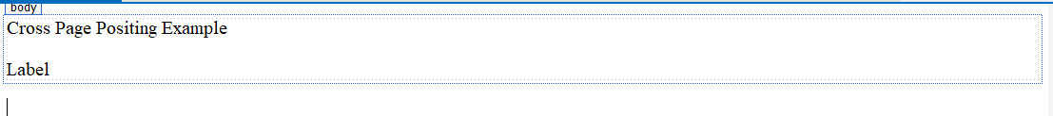

**Gui2.aspx.cs:**

using System;

using System.Collections.Generic; using System.Linq;

using System.Web; using System.Web.UI;

using System.Web.UI.WebControls;

namespace practical2_A

{

publicpartialclassGui2 : System.Web.UI.Page

{

protectedvoid Page_Load(object sender, EventArgs e)

{

if(Page.PreviousPage!=null&& PreviousPage.IsCrossPagePostBack)

{

Button: "

}

}

}

}

Calendar Cal1 = new Calendar(); TextBox txtMyName = new TextBox();

Cal1 = (Calendar)(PreviousPage.FindControl("Calendar1")); txtMyName = (TextBox)(PreviousPage.FindControl("txtName"));

Label2.Text = "<br/>Hi " + txtMyName.Text + ", Here is output of the Page Post Back

+ Cal1.SelectedDate.ToString("dd / MM / yyyy");

# Gui2.aspx:

<%@PageLanguage="C#"AutoEventWireup="true"CodeBehind="Gui2.aspx.cs"Inherits="practic al2_A.Gui2"%>

<!DOCTYPEhtml>

<htmlxmlns="<http://www.w3.org/1999/xhtml>">

<headrunat="server">

<title></title>

</head>

<body>

<formid="form1"runat="server">

<div>

<asp:LabelID="Label1"runat="server"ForeColor="Black"Text="Cross Page Positing Example"></asp:Label>

<br/>

<br/>

<asp:LabelID="Label2"runat="server"Text="Label"></asp:Label>

</div>

</form>

</body>

</html>

# Output:

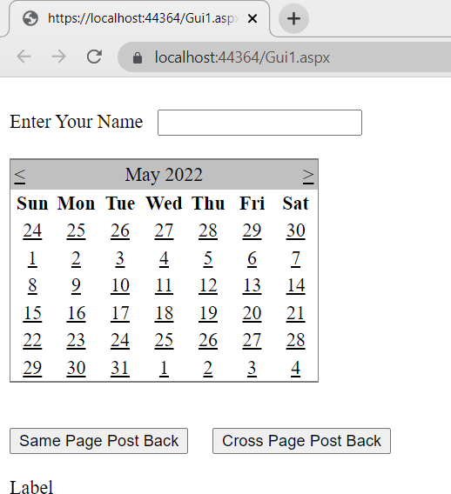

**Postback Posting:**

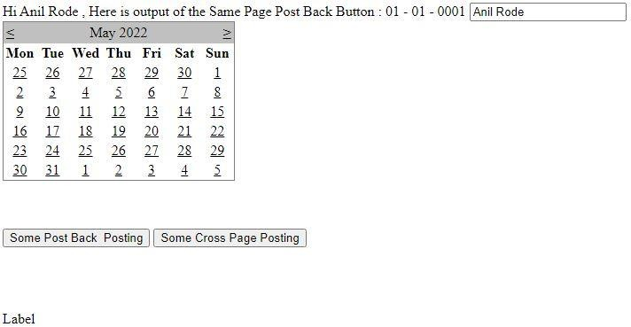

# Design asp.net web form to demonstrate FileUpload, Calendar and AdRotator controls.

**Design:**

# FileUpload:

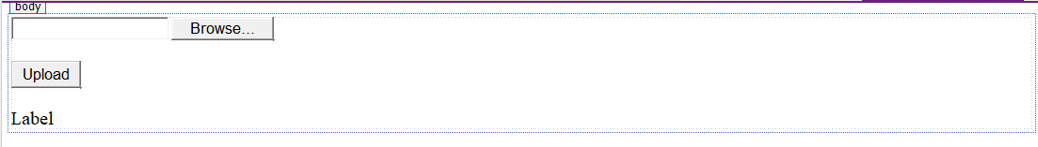

**Code:**

# FileUpload.aspx:

<%@PageLanguage="C#"AutoEventWireup="true"CodeBehind="FileUpload.aspx.cs"Inherit s="practical2_A.FileUpload"%>

<!DOCTYPEhtml>

<htmlxmlns="<http://www.w3.org/1999/xhtml>">

<headrunat="server">

<title></title>

</head>

<body>

<formid="form1"runat="server">

<div>

<asp:FileUploadID="FileUpload1"runat="server"/>

<br/>

<br/>

<asp:ButtonID="BtnUpload"runat="server"OnClick="BtnUpload_Click"Text="Upload"/>

<br/>

<br/>

<asp:LabelID="lblUploadStatus"runat="server"Text="Label"></asp:Label>

<br/>

</div>

</form>

</body>

</html>

# FileUpload.aspx.cs

using System;

using System.Collections.Generic; using System.Linq;

using System.Web; using System.Web.UI;

using System.Web.UI.WebControls;

namespace practical2_A

{

publicpartialclassFileUpload : System.Web.UI.Page

{

protectedvoid BtnUpload_Click(object sender, EventArgs e)

{

if (FileUpload1.HasFile) try

{

FileUpload1.SaveAs("D:\\" + FileUpload1.FileName); lblUploadStatus.Text = "File Uploaded Sucessfully !!" +

FileUpload1.PostedFile.ContentLength + "mb";

}

catch(Exception ex)

{

lblUploadStatus.Text = "File Not Uploaded!!" + ex.Message.ToString();

else

}

}

}

}

{

lblUploadStatus.Text = "Please Select File And Upload Again";

}

# Output:

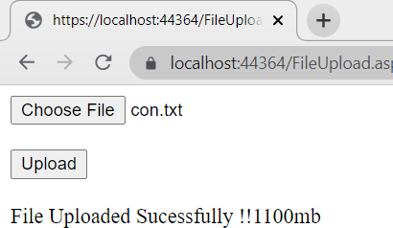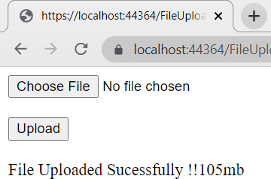

**Design: AdRotator:**



# Code:

**AdRotator.aspx**

<%@PageLanguage="C#"AutoEventWireup="true"CodeBehind="AdRotator.aspx.cs"Inherits

="practical2_A.AdRotator"%>

<!DOCTYPEhtml>

<htmlxmlns="<http://www.w3.org/1999/xhtml>">

<headrunat="server">

<title></title>

</head>

<body>

<formid="form1"runat="server">

<div>

<asp:AdRotatorID="AdRotator1"runat="server"AdvertisementFile="~/adverXML.xml"/>

</div>

<p> &nbsp;</p>

</form>

</body>

</html>

# Output:

**AdRotator:**



# Design:

**Calendar Control:**

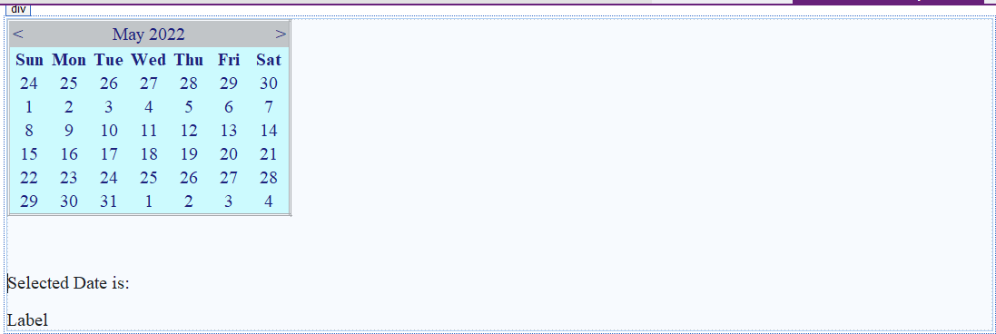

# Code: CalenderControl.aspx:

<%@PageLanguage="C#"AutoEventWireup="true"CodeBehind="CalenderControl.aspx.cs"Inhe rits="practical2_A.CalenderControl"%>

<!DOCTYPEhtml>

<htmlxmlns="<http://www.w3.org/1999/xhtml>">

<headrunat="server">

<title></title>

</head>

<body>

<formid="form1"runat="server">

<div>

<asp:CalendarID="Calendar1"runat="server"BackColor="#CCFFFF"BorderStyle="Double"Fore Color="#000066"OnSelectionChanged="Calendar1_SelectionChanged"></asp:Calendar>

<br/>

<br/>

<p>Selected Date is:</p><asp:LabelID="LblDate"runat="server"Text="Label"></asp:Label>

</div>

</form>

</body>

</html>

# CalenderControl.aspx.cs

using System;

using System.Collections.Generic; using System.Linq;

using System.Web; using System.Web.UI;

using System.Web.UI.WebControls; namespace practical2_A

{

publicpartialclassCalenderControl : System.Web.UI.Page

{

protectedvoid Calendar1_SelectionChanged(object sender, EventArgs e)

{

LblDate.Text = Calendar1.SelectedDate.ToShortDateString();

}

}

}

# Output:

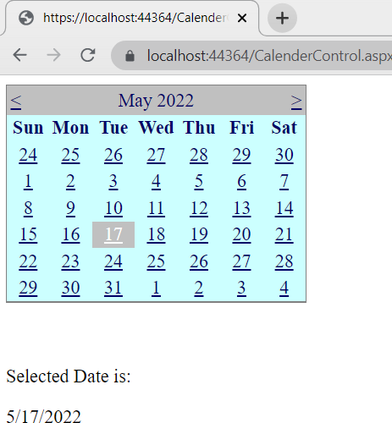

1. **Design asp.net web form to demonstrate Validation controls in asp.net. After successful submission of data, show same data on another page.**

# Design:

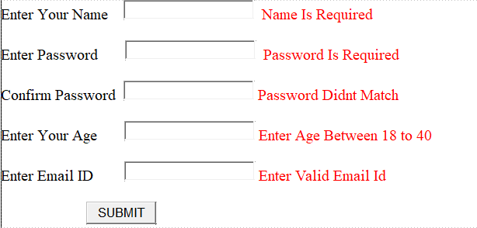

**Code: ValidationControl.aspx**

<%@PageLanguage="C#"AutoEventWireup="true"CodeBehind="ValidationControl.aspx.cs" Inherits="practical2_A.ValidationControl"%>

<!DOCTYPEhtml>

<htmlxmlns="<http://www.w3.org/1999/xhtml>">

<headrunat="server">

<title></title>

</head>

<body>

<formid="form1"runat="server">

<div>

<asp:LabelID="Label1"runat="server"Text="Enter Your Name"></asp:Label>

<asp:TextBoxID="TextName"runat="server"></asp:TextBox>

<asp:RequiredFieldValidatorID="RequiredFieldValidator1"runat="server"ControlToValidate= "TextName"ErrorMessage="Name Is Required"ForeColor="Red"></asp:RequiredFieldValidator>

<br/>

<br/>

<asp:LabelID="Label2"runat="server"Text="Enter Password"></asp:Label>

<asp:TextBoxID="TextPassword"runat="server"></asp:TextBox>

<asp:RequiredFieldValidatorID="RequiredFieldValidator2"runat="server"ControlToValidate= "TextPassword"ErrorMessage="Password Is Required"ForeColor="Red"></asp:RequiredFieldValidator>

<br/>

<br/>

<asp:LabelID="Label3"runat="server"Text="Confirm Password"></asp:Label> &nbsp;

<asp:TextBoxID="TextCnPassword"runat="server"></asp:TextBox> &nbsp;<asp:CompareValidatorID="CompareValidator1"runat="server"ControlToCompare=" TextPassword"ControlToValidate="TextCnPassword"ErrorMessage="Password Didnt Match"ForeColor="Red"></asp:CompareValidator>

<br/>

<br/>

<asp:LabelID="Label4"runat="server"Text="Enter Your Age"></asp:Label>

<asp:TextBoxID="TextAge"runat="server"></asp:TextBox> &nbsp;<asp:RangeValidatorID="RangeValidator1"runat="server"ControlToValidate="TextAg e"ErrorMessage="Enter Age Between 18 to 40"ForeColor="Red"MaximumValue="40"MinimumValue="18"></asp:RangeValidator>

<br/>

<br/>

<asp:LabelID="Label5"runat="server"Text="Enter Email ID"></asp:Label>

<asp:TextBoxID="TextEmail"runat="server"></asp:TextBox> &nbsp;<asp:RegularExpressionValidatorID="RegularExpressionValidator1"runat="server"Co ntrolToValidate="TextEmail"ErrorMessage="Enter Valid Email Id"ForeColor="Red"ValidationExpression="\w+([-+.']\w+)*@\w+([-.]\w+)*\.\w+([-

.]\w+)*"></asp:RegularExpressionValidator>

<br/>

<asp:ButtonID="btnSubmit"runat="server"OnClick="btnSubmit_Click"Text="SUBMIT"PostBa ckUrl="~/DisplayDetails.aspx"/>

</div>

</form>

</body>

</html>

# Output:

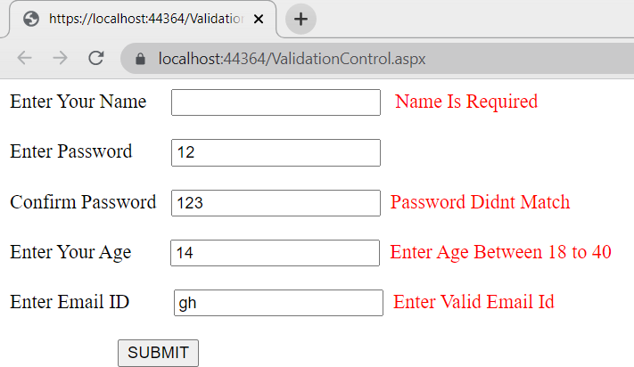

1. 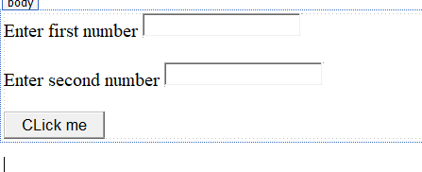**Design asp.net web form to demonstrate JQuery (use CDN JQuery library). Design:**

# Code: JQueryCDN.aspx:

<%@PageLanguage="C#"AutoEventWireup="true"CodeBehind="JQueryCDN.aspx.cs"Inherits=" Practical2.JQueryCDN"%>

<!DOCTYPEhtml>

<htmlxmlns[="http://www.w3.org/1999/xht](http://www.w3.org/1999/xhtml)ml">

<headrunat="server">

<title></title>

<scriptsrc="https://ajax.googleapis.com/ajax/libs/jquery/3.3.1/jquery.min.js"></sc ript>

</head>

<script>

$(document).ready(function () {

$("button").click(function () {

var num1 = $("#num1").val();

var num2 = $("#num2").val();

var multiplication = parseInt(num1) * parseInt(num2);

alert("Multiplication is : " + multiplication);

});

});

</script>

</head>

<body>

<formid="form1"runat="server">

<div>

<asp:LabelID="Label1"runat="server"Text="Enter first number"></asp:Label> &nbsp;<inputtype="text"id="num1"placeholder="Enter first number"/></br></br>

<asp:LabelID="Label2"runat="server"Text="Enter second number"></asp:Label> &nbsp;<inputtype="text"id="num2"placeholder="Enter Second number"/></br></br>

<button>CLick me</button>

</div>

</form>

</body>

</html>

**Output:**

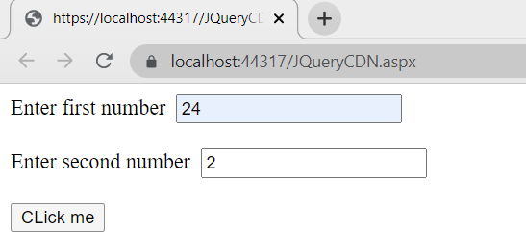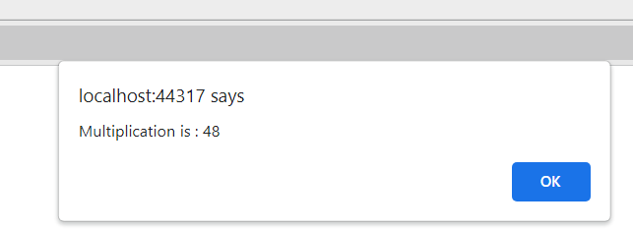

# Design asp.net web form to demonstrate JQuery (download and use local JQuery library).

**Design:**



# Code: JQueryLocal.aspx:

<%@PageLanguage="C#"AutoEventWireup="true"CodeBehind="JQueryCDN.aspx.cs"Inherits= "Practical2.JQueryCDN"%>

<!DOCTYPEhtml>

<htmlxmlns="<http://www.w3.org/1999/xhtml>">

<headrunat="server">

<title></title>

<scriptsrc="Scripts/jquery-3.2.1.js"></script>

<script>

$(document).ready(function () {

$("button").click(function () {

var num1 = $("#num1").val();

var num2 = $("#num2").val();

var sum = parseInt(num1) + parseInt(num2); alert("Addition is : "+sum);

});

});

</script>

</head>

<body>

<formid="form1"runat="server">

<div>

<asp:LabelID="Label1"runat="server"Text="Enter first number"></asp:Label> &nbsp;<inputtype="text"id="num1"placeholder="Enter first number"/></br></br>

<asp:LabelID="Label2"runat="server"Text="Enter second number"></asp:Label> &nbsp;<inputtype="text"id="num2"placeholder="Enter Second number"/></br></br>

<button>CLick me</button>

</div>

</form>

</body>

</html>

# Output:

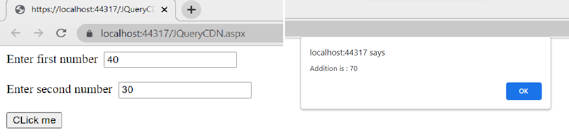

1. 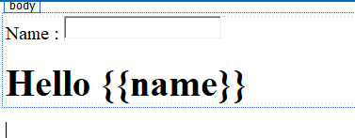**Design asp.net web form to demonstrate AngularJS (use CDN). Design:**

# Code: AngularJsCDN.aspx:

<%@PageLanguage="C#"AutoEventWireup="true"CodeBehind="AngularJs.aspx.cs"Inherits="p ractical2_A.AngularJs"%

<!DOCTYPEhtml>

<htmlxmlns="<http://www.w3.org/1999/xhtml>">

<headrunat="server">

<title></title>

</head>

<script src="https://ajax.googleapis.com/ajax/libs/angularjs/1.6.9/angular.min.js"></script>

<body>

<formid="form1"runat="server">

<divng-app="">

<p>Name : <inputtype="text"ng-model="name"></p>

<h1>Hello **{{**name**}}**</h1>

</div>

</form>

</body>

</html>

# Output:

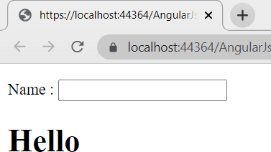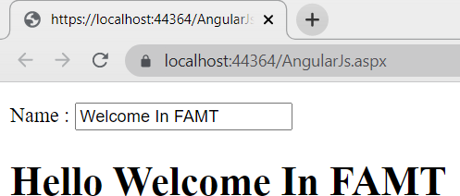

1. **Design asp.net web form to demonstrate AngularJS (download and use local library).**

# Design:

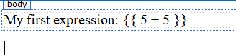

**Code: AngularJs2.aspx:**

<%@PageLanguage="C#"AutoEventWireup="true"CodeBehind="AngularJs2.aspx.cs"Inherits=" practical2_A.AngularJs2"%>

<!DOCTYPEhtml>

<htmlxmlns="<http://www.w3.org/1999/xhtml>">

<headrunat="server">

<title></title>

<scriptsrc="AngularJs/angular.min.js">

</script>

</head>

<body>

<formid="form1"runat="server">

<divng-app="">

<p>My first expression: **{{**5+5**}}**</p>

</div>

</form>

</body>

</html>

# Output:

